Chaplin invented an alter ego which best represented our

intrinsic needs in a more and more demanding society,

an alter ego on the scale of 20th century man:

a simple character facing the complexity of the industrial world.

~André Bazin, film theorist and critic

-----------------------------------------------------------------------------------------------------------------------------------

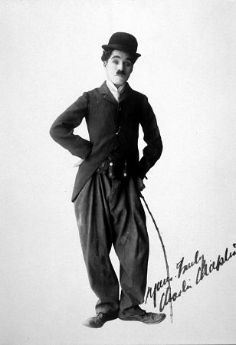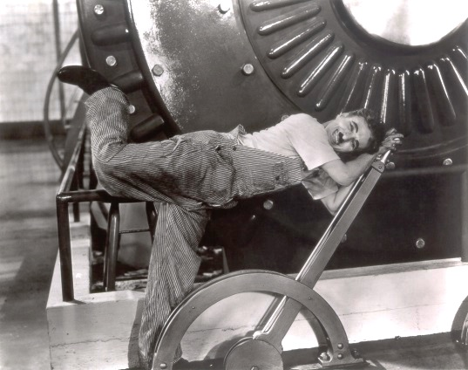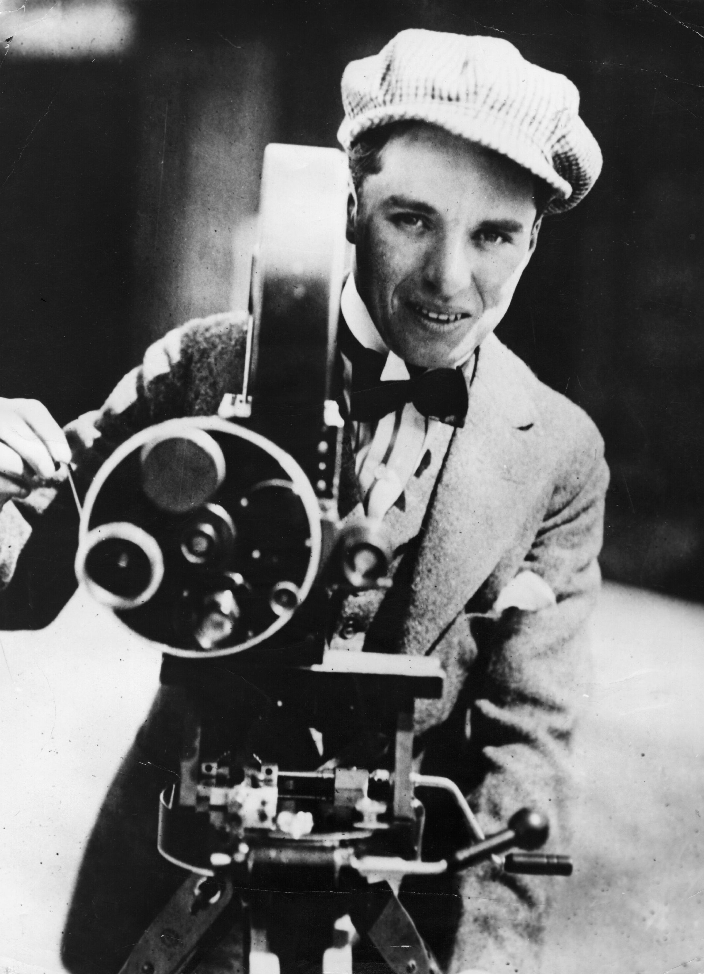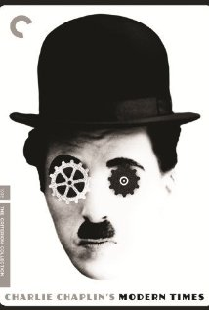

-----------------------------------------------------------------------------------------------------------------------------------

Filming Modern Times (1935-36)
Text by David Robinson (c) 2004 MK2 SA
(Selections sourced from CharlieChaplin.com)

Modern Times marked the last screen appearance of the Little Tramp—the character which had brought Charles Chaplin world fame, and who still remains the most universally recognized fictional image of a human being in the history of art.
The world from which the Tramp took his farewell was very different from that into which he had been born in England, two decades earlier, before the First World War. Then he had shared and symbolized the hardships of all the underprivileged of a world only just emerging from the 19th century. Modern Times found him facing very different predicaments in the aftermath of America’s Great Depression, when mass unemployment coincided with the massive rise of industrial automation.
Film as Social Commentary
Chaplin was acutely preoccupied with the social and economic problems of this new age. In 1931 and 1932 he had left Hollywood behind to embark on an 18-month world tour. In Europe, he had been disturbed to see the rise of nationalism and the social effects of the Depression, of unemployment and of automation. He read books on economic theory and devised his own Economic Solution, an intelligent exercise in Utopian idealism, based on a more equitable distribution not just of wealth, but of work. In 1931 he told a newspaper interviewer:

Unemployment is the vital question …
Machinery should benefit mankind. It should
not spell tragedy and throw it out of work.

In Modern Times, Chaplin set out to transform his observations and anxieties into comedy. The little Tramp—described in the film credits as “a Factory Worker”—is now one of the millions coping with the problems of the 1930s, which are not so very different from anxieties of the 21st century: poverty, unemployment, strikes and strike breakers, political intolerance, economic inequalities, the tyranny of the machine, narcotics. The film’s portentous opening title,

The story of industry, of individual enterprise,
humanity crusading in the pursuit of happiness

is followed by a symbolic juxtaposition of shots of sheep being herded and of workers streaming out of a factory. Chaplin’s character is first seen as a worker being driven crazy by his monotonous, inhuman work on a conveyor belt and being used as a guinea pig to test a machine to feed workers as they work.

Paulette Goddard

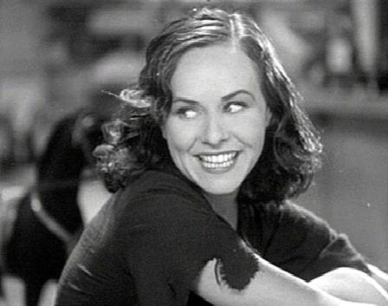
Exceptionally, the Tramp has a companion in his battle with this new world. On his return to America after a world tour in 1931, Chaplin had met the actress Paulette Goddard, who was to remain, for several years, an ideal partner in his private life.

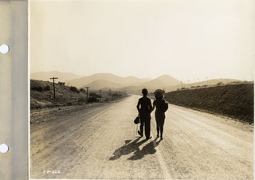
Goddard’s personality inspired the character of the “Gamine” in Modern Times—a young girl whose father has been killed in a labor demonstration, and who joins forces with Chaplin. The two are neither rebels nor victims in the story, but, wrote Chaplin, “the only two live spirits in a world of automatons . . . children with no sense of responsibility, whereas the rest of humanity is weighed down with duty. We are spiritually free.” In a sense, then, they are anarchists.

The Power of Voice: Human and Otherwise
By the time Modern Times was released, talking pictures had been established for almost a decade. Till now, Chaplin had resisted dialogue, knowing that his comedy and its universal understanding depended on silent pantomime. This time though he weakened to the extent of preparing dialogue, and even doing some trial recordings. Finally he thought better of it, and as in his film City Lights, uses only music and sound effects. Human voices are only heard filtered through technological devices—the boss who addresses his workers from a television screen, the salesman who is only a voice on the phonograph.
In one moment, though, Chaplin’s own voice is heard directly. Hired as a waiter, the Little Worker is required to stand in for the romantic café tenor. He writes the words on his shirt cuffs, but these fly off with a too-dramatic flourish; and he is obliged to improvise the song in a wonderful, mock-Italian gibberish. Chaplin’s voice had already been heard on radio and in at least one newsreel, but this was the first and only time that the world heard speech from the Little Tramp.
Chaplin the Composer
Even many of Chaplin’s fans are unaware that he was as much a musician as he was an actor and director. As he had done for City Lights (and most of his other films), Chaplin himself scored Modern Times, giving his arrangers and conductors a harder time than usual. The distinguished Hollywood musician Alfred Newman walked off the film.

The Challenge of Sound
The arrival of sound films was an enormous challenge for Chaplin. He had won world fame with the universal language of pantomime. If the Little Tramp now began to speak in English, he would become incomprehensible to a large part of his international audience. In 1931 he predicted that talking pictures would not last six months, and told an interviewer that “Dialogue may or may not have a place in comedy … dialogue does not have a place in the sort of comedies I make ... For myself, I know that I cannot use dialogue.”

When the interviewer asked him if he had tried using speech in his films, he retorted: “I never tried jumping off the monument in Trafalgar Square, but I have a definite idea that it would be unhealthful… For years I have specialized in one type of comedy—strictly pantomime. I have measured it, gauged it, studied it. I have been able to establish exact principles to govern its reactions on audiences. It has a certain pace and tempo. Dialogue, to my way of thinking, always slows action, because action must wait upon words.”
Chaplin did proceed with sound effects, however, and took a personal interest in the technique of their creation. For a scene involving rumbling stomachs, he created the noises himself by blowing bubbles into a pail of water. The fact that Chaplin was sufficiently keen to create the effects himself in this way suggests the extent to which he was intrigued by sound problems at this time. A memorandum about possible musical effects notes: “Natural sounds part of composition, i.e. Auto horns, sirens, and cowbells worked into the music.” The sound effects became an element of the musical score.

The Premieres

Chaplin and his co-star Paulette Goddard attended the third and the most glamorous premiere in Hollywood (following the New York and London premieres) on 12 February, 1936, at Grauman’s Chinese Theatre. Guests were handed programs designed in lush Art Deco style, printed in black and red on gold paper. The most notable item in the program was a new “Silly Symphony” cartoon from Walt Disney Studios, Mickey’s Orphan Concert. The inclusion of this cartoon exemplified an intense mutual admiration between Chaplin and Disney, who recognized similarities in each other’s work. Disney bought advertising space in the program:

In appreciation of the pantomimist supreme whose inimitable artistry and craftsmanship are timeless.
It was signed, “Mickey Mouse and Walt Disney.”

